Pandas Proof

Problem 1:

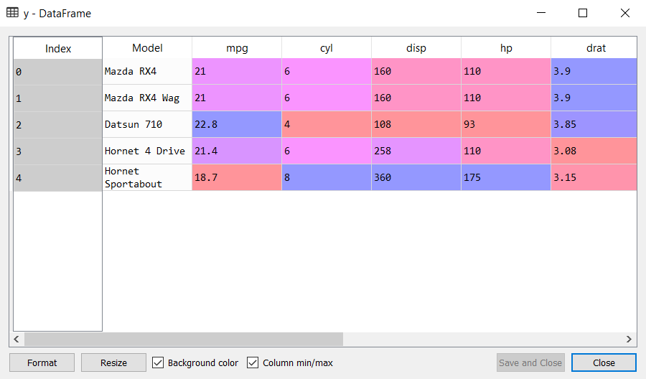

*The y-DataFrame showing the first five rows of cars*

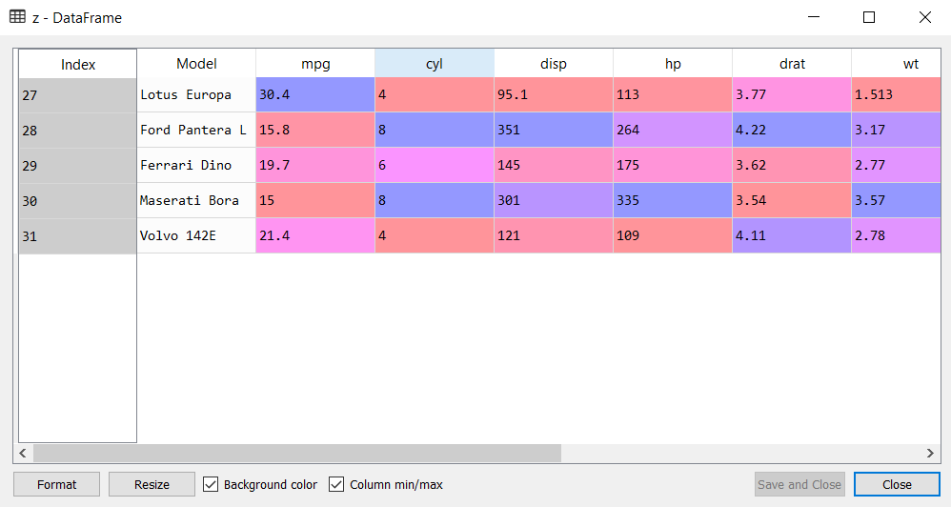

*The z-DataFrame showing the last five rows of cars*

Problem 2:

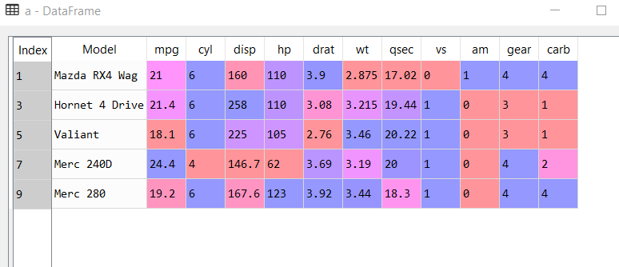

*a-DataFrame showing odd numbered cars info*

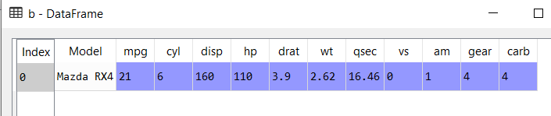

*b-DataFrame showing information about Mazda RX4*

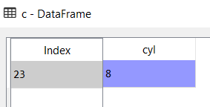

*c-DataFrame showing the number of cylinders of Camaro Z28*

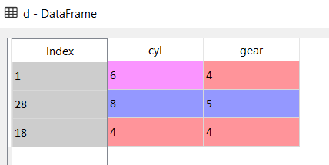

*d-DataFrame showing the number of cylinder and gear type of the 3 cars, Mazda RX4, Ford Pantera L and Honda Civic*